- AIM: To Create a simple cloud software application for Flight Reservation System using any Cloud
Service Provider to demonstrate SaaS include the necessary fields such as one way, round
trip, From, to, Departure, Departure, Travelers &amp; Class, Fare Type, International and
Domestic Flights etc.
Procedure: Choose a cloud service provider such as AWS, Google Cloud, or Microsoft Azure.
- Create a cloud-based application for the Flight Reservation System.
- Design the booking form with fields like One Way/Round Trip, From, To, Departure, Return, Travelers and Class.
- Add Fare Type options such as Economy, Business, etc.
- Provide options for Domestic and International Flights.
- Create a database to store flight details and passenger information.
- Implement flight search and reservation functionality.
- Deploy the application on the selected Cloud Service Provider.
- Test the application by searching and booking a flight.
- Access the application through a web browser to demonstrate SaaS.

Output:
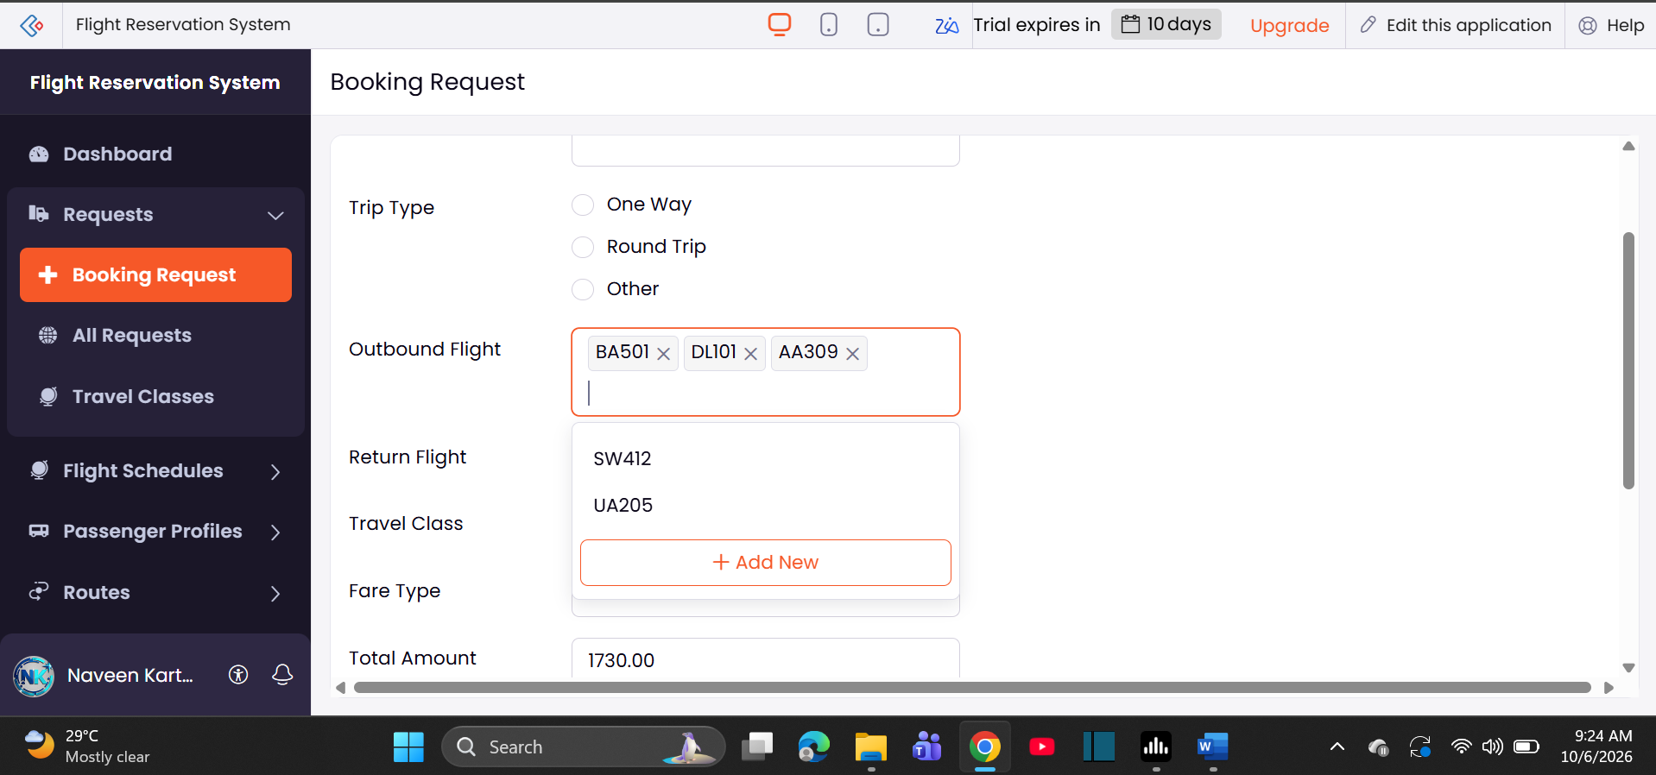
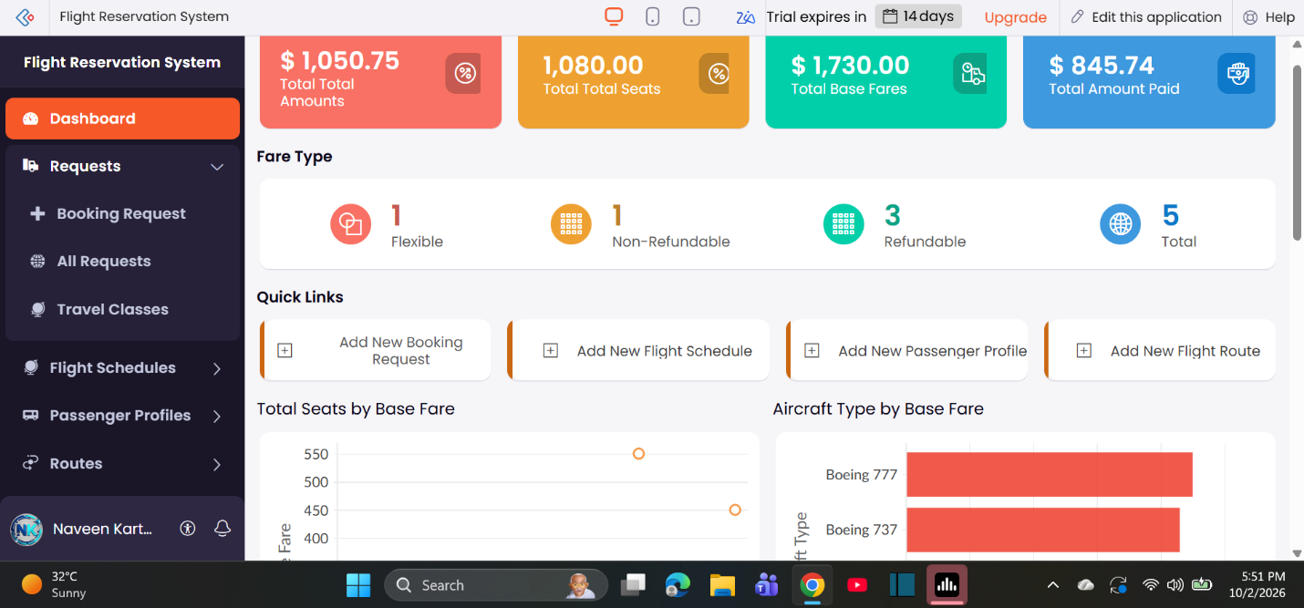

- AIM: To Create a simple cloud software application for Property Buying &amp; Rental process (In Chennai
city) using any Cloud Service Provider to demonstrate SaaS include the necessary fields such
as Buy, Rent, commercial, Rental Agreement , Rental Agreement, Area, place, Range,
property value etc.
Procedure:
- Choose a Cloud Service Provider such as AWS, Google Cloud, or Microsoft Azure.
- Create a cloud-based Property Buying and Rental application for Chennai.
- Design a form with options for Buy, Rent, and Commercial properties.
- Add fields such as Area, Place, Price Range, and Property Value.
- Include Rental Agreement details for rental properties.
- Create a database to store property and customer details.
- Implement property search, filtering, buying, and rental features.
- Deploy the application on the selected Cloud Service Provider.
- Test the application by searching and selecting properties.
- Access the application through a web browser to demonstrate SaaS.

Output:
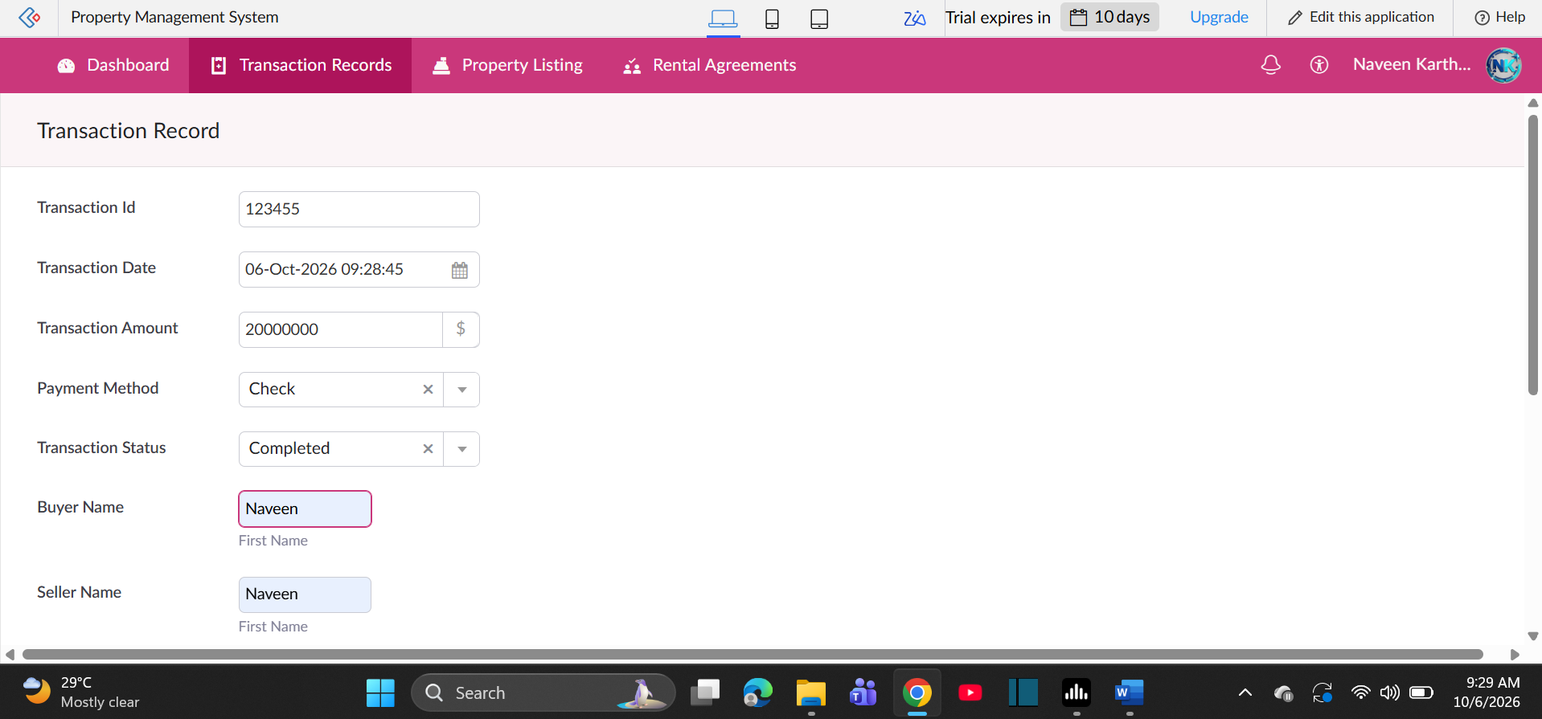
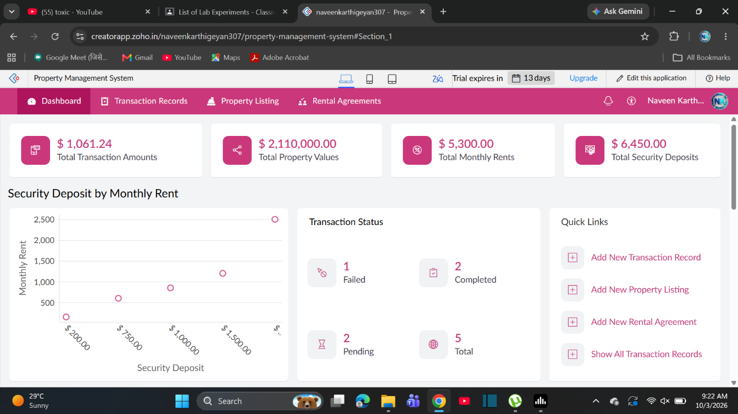

- AIM: To Create a simple cloud software application for Car Booking Reservation System using any
Cloud Service Provider to demonstrate SaaS include the necessary fields such as search for
cabs, from, to, rental , out station, Package type, hours/Days etc.
Output:
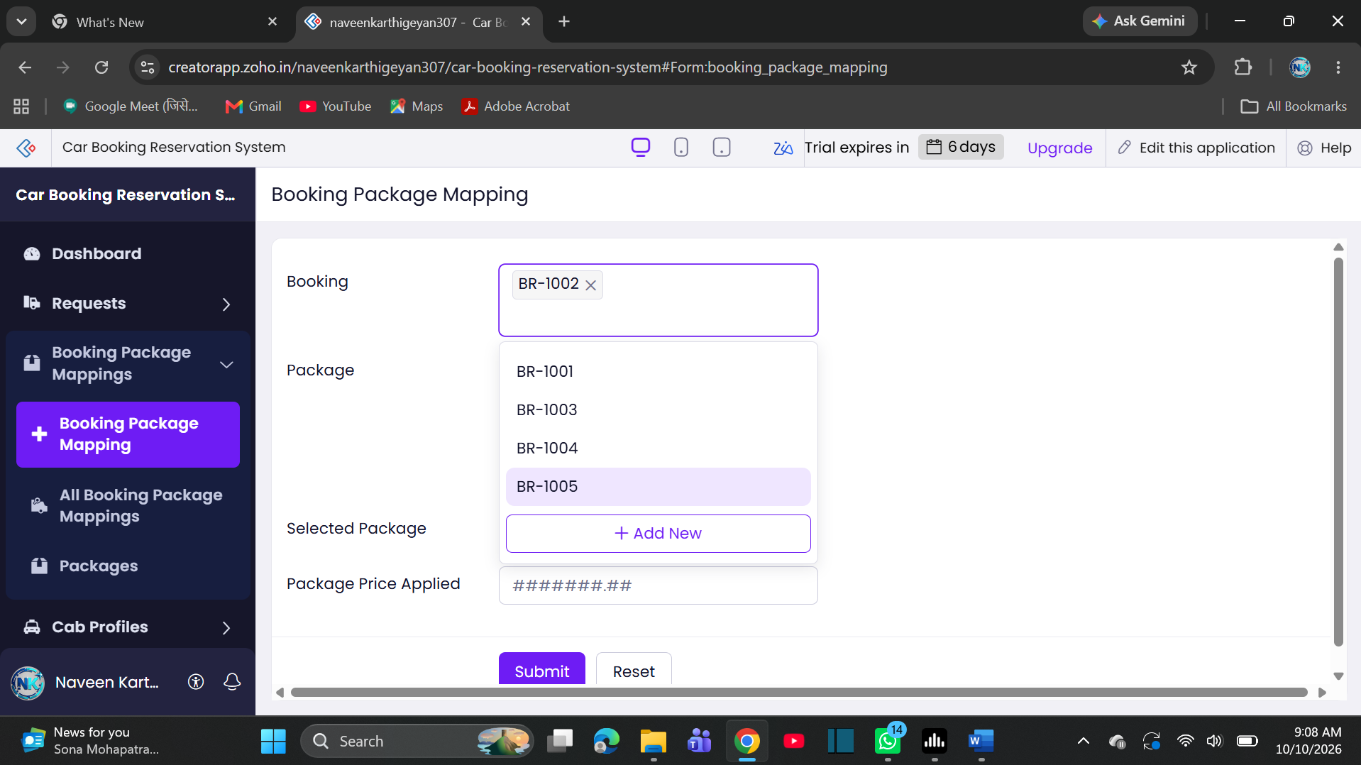
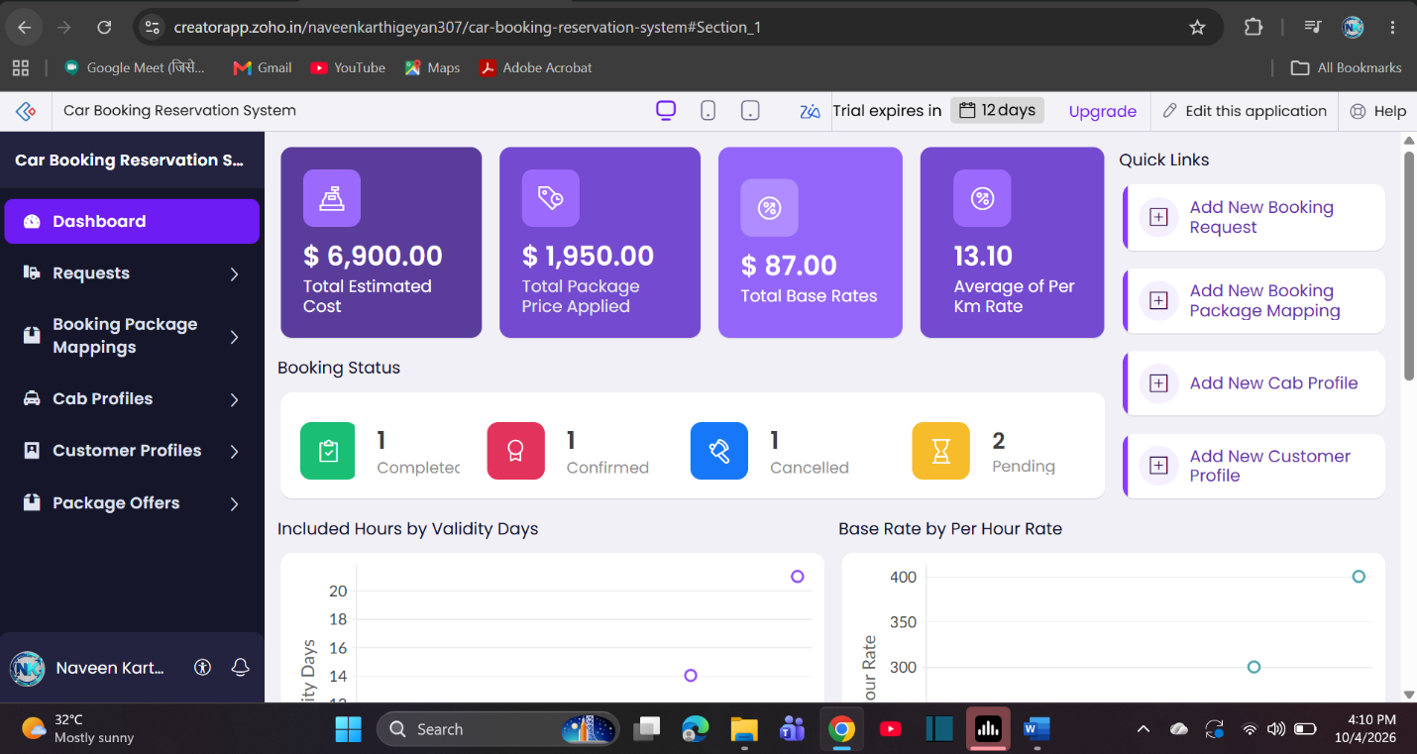

- AIM: To Create a simple cloud software application for Library book reservation system for SIMATS
library using any Cloud Service Provider to demonstrate SaaS include the necessary fields
such as Title of the book, author, publications, Year, edition, no of copies, Rack no, status
(taken/returned) etc.
Output:
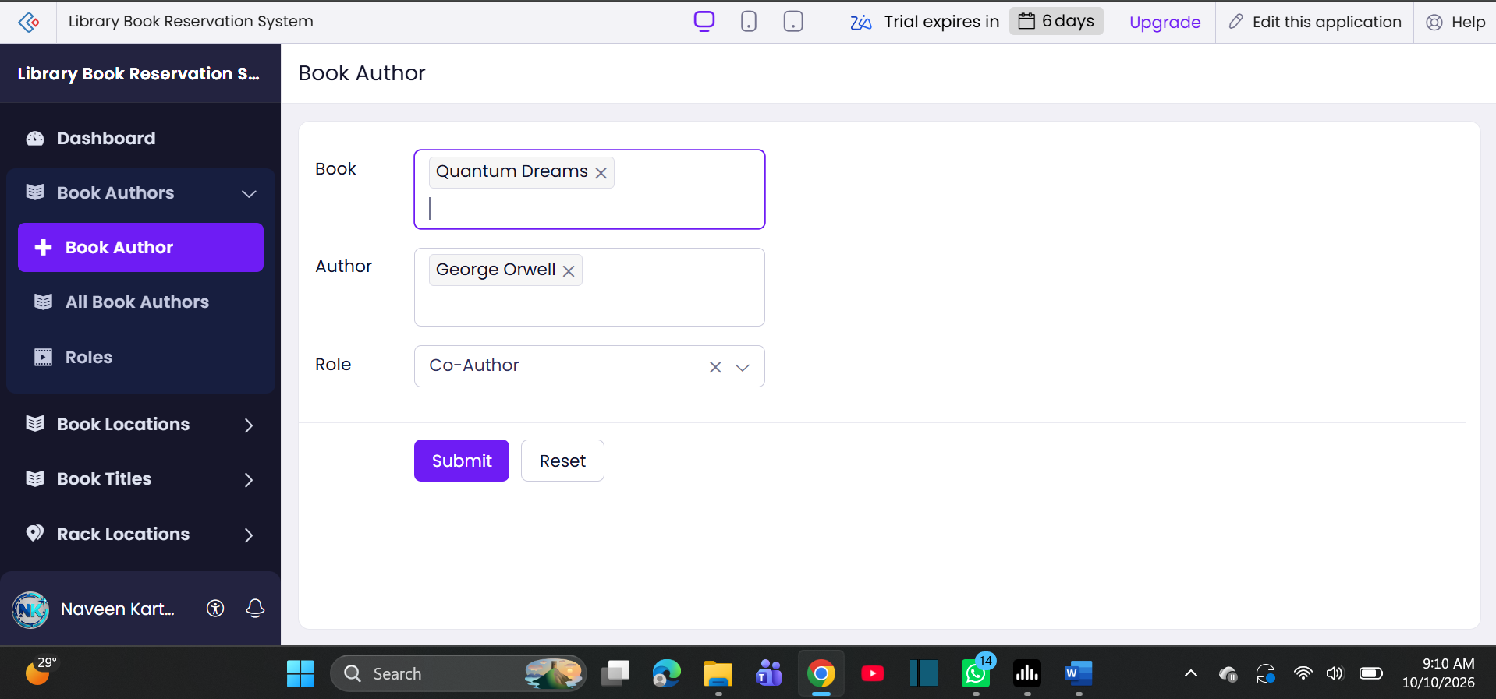
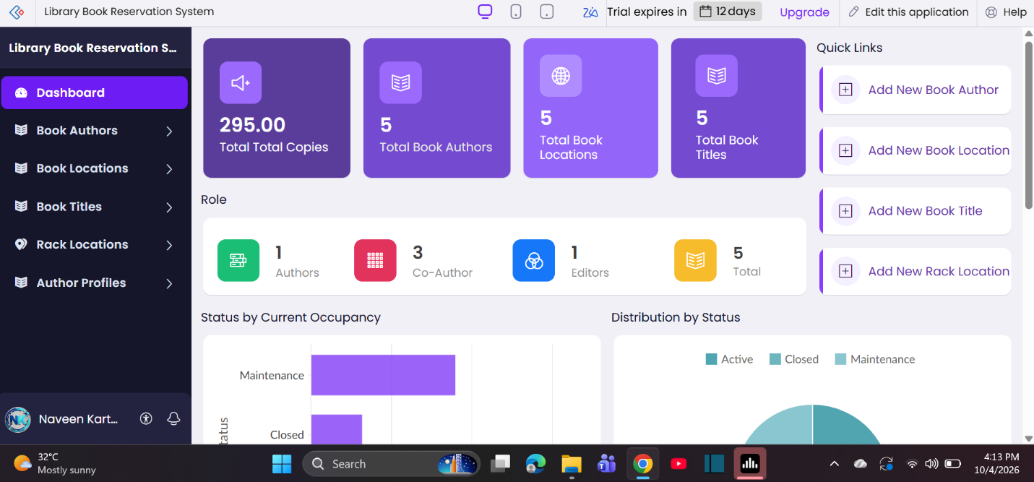

- AIM: To Create a simple cloud software application for Mark Sheet Processing System using any
Cloud Service Provider to demonstrate SaaS include the necessary fields such as name of the
student, Reg no of the student , Subjects , Marks, Average, percentage, rank, overall
performance etc.
Output:
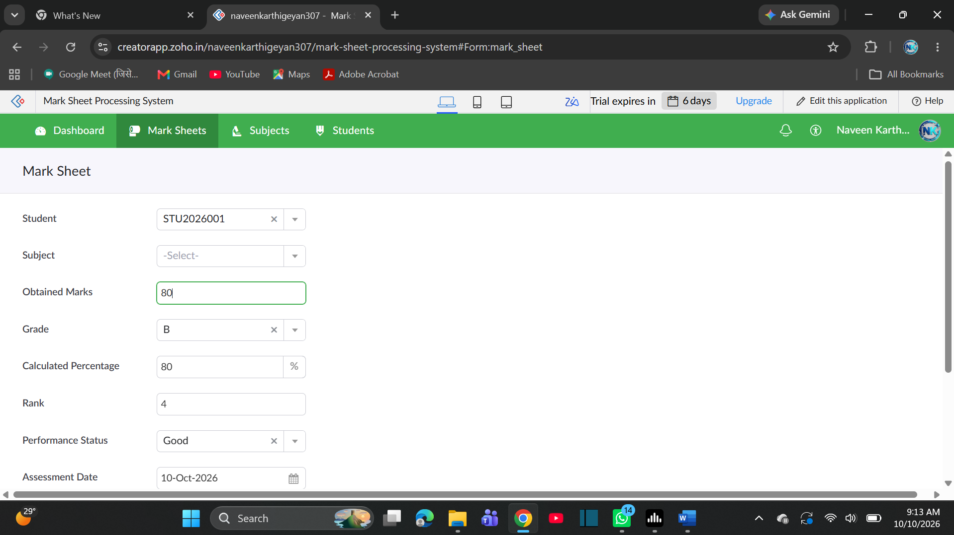
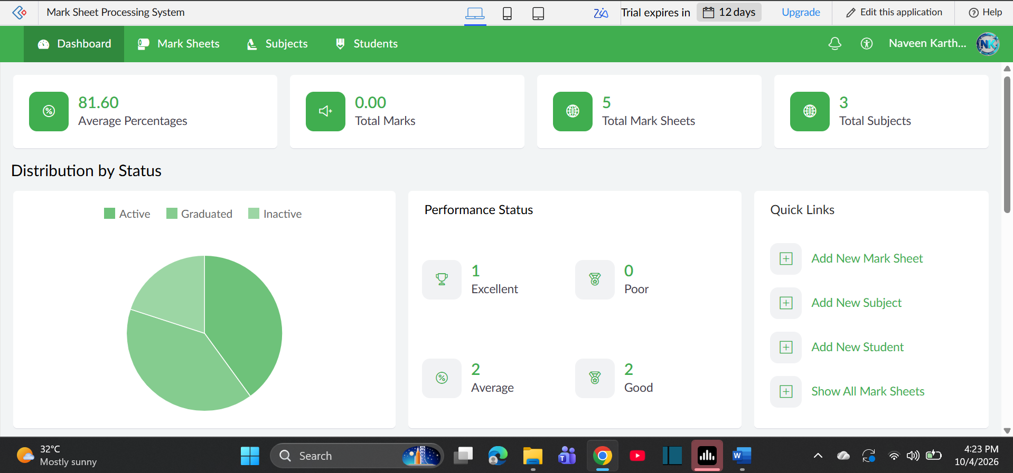

- AIM: To Create a simple cloud software application for Payroll Processing System using any Cloud
Service Provider to demonstrate SaaS include the necessary fields such as Name of the
employee, experience in present org , over all experience, basic pay, HRA, DA, TA, net pay,
gross pay etc.
Output:
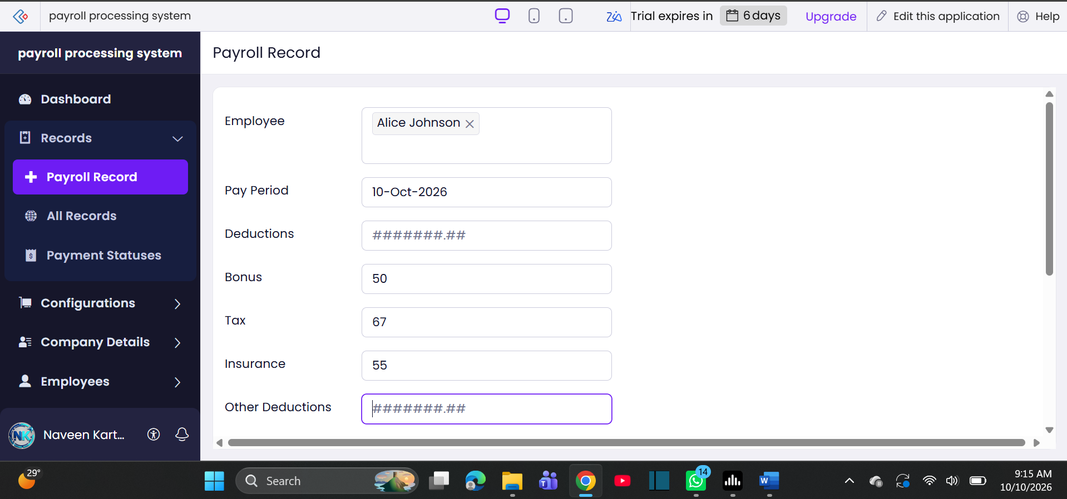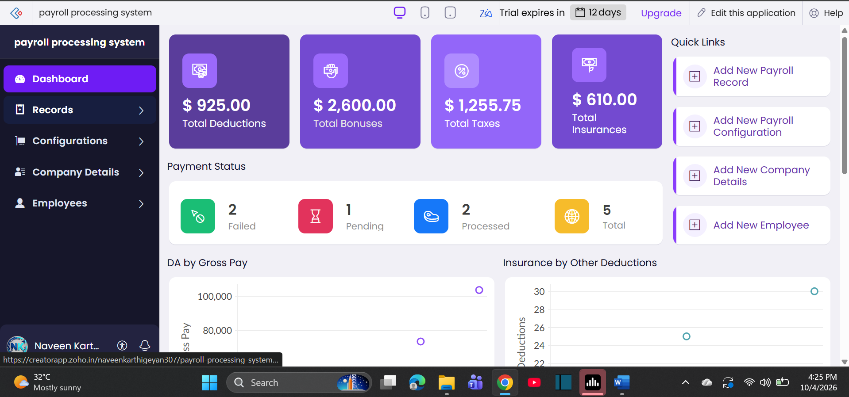

- AIM: To Create a simple cloud software application for Students Attendance System using any Cloud
Service Provider to demonstrate SaaS include the necessary fields such as name of the
students, course, present , Absent, course attendance, OD request, grade, attendance
percentage, etc.
Output: 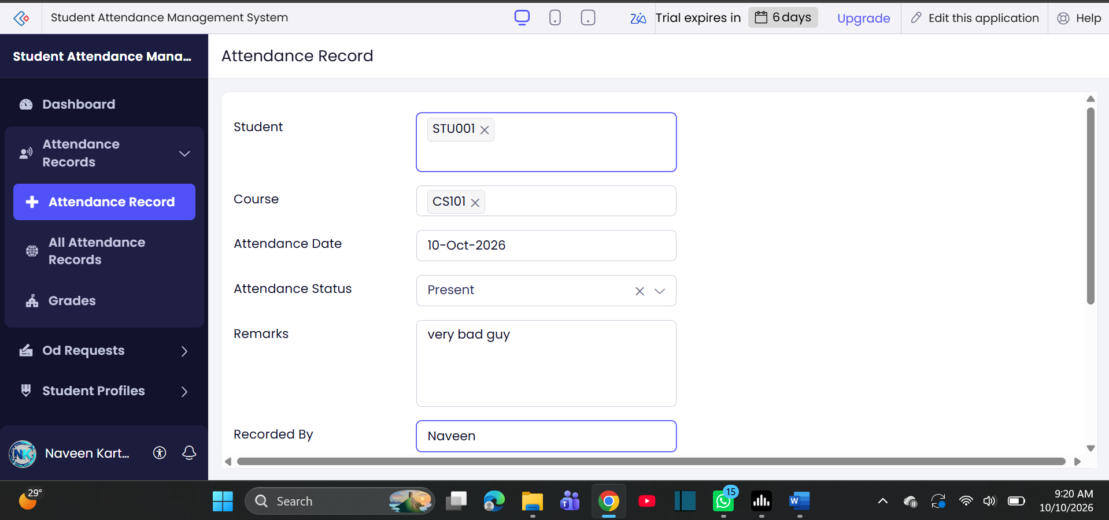
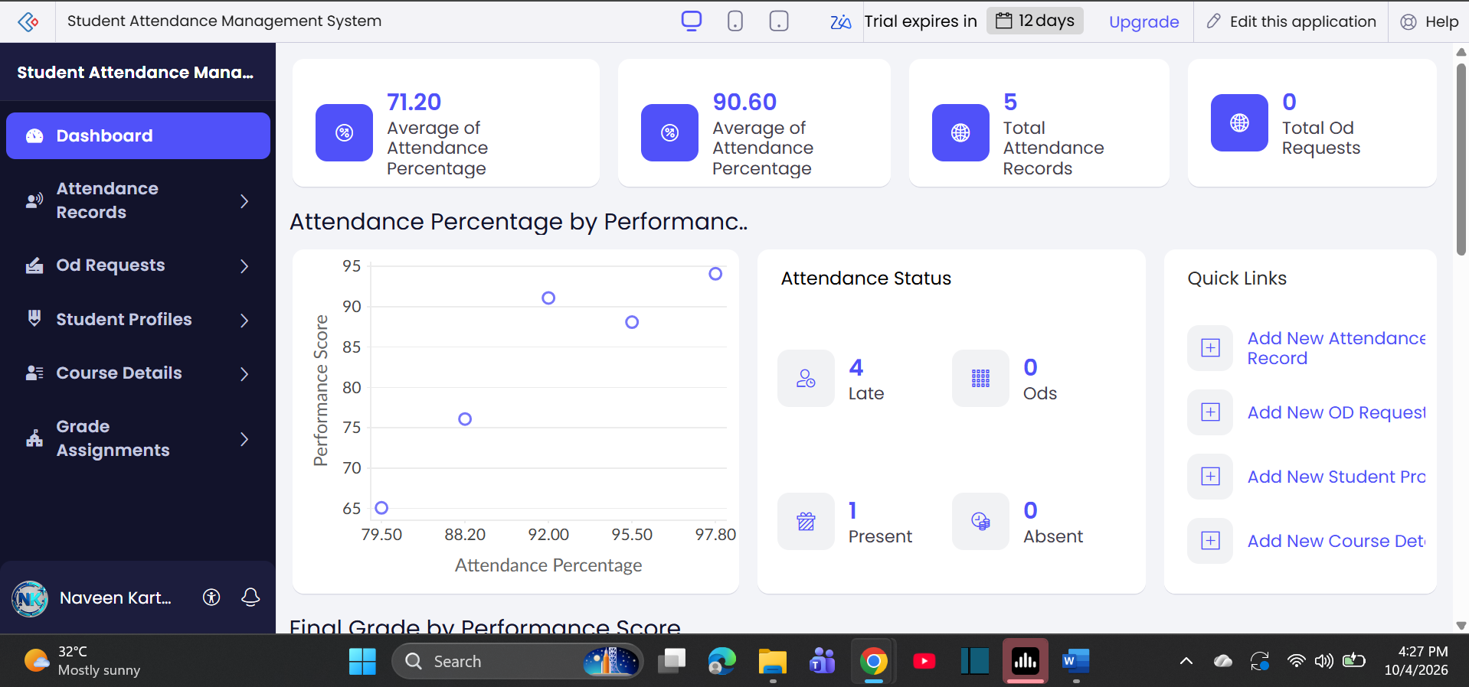

- AIM: Create a simple cloud web application for student counselling system using any Cloud
Service Provider to demonstrate SaaS with the fields of student name, age, address, phone,
subjects studied, Year of passing, percentage of marks, domain interest, etc.
Output:
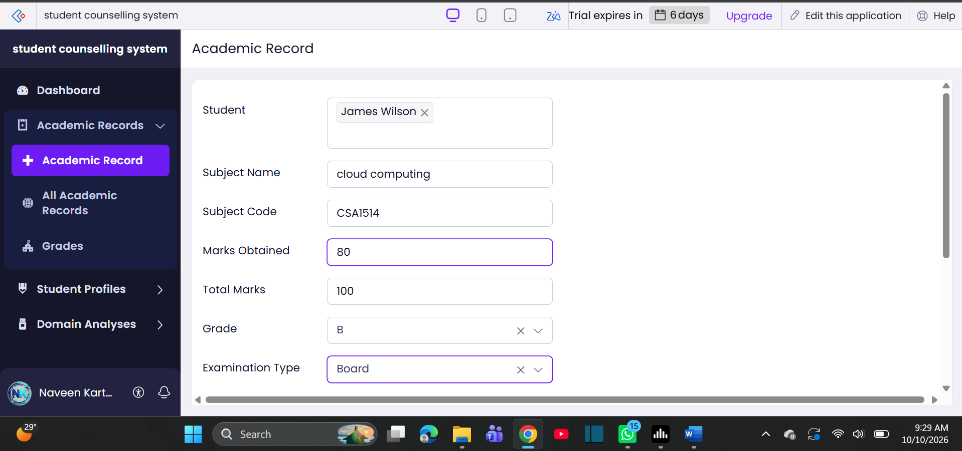
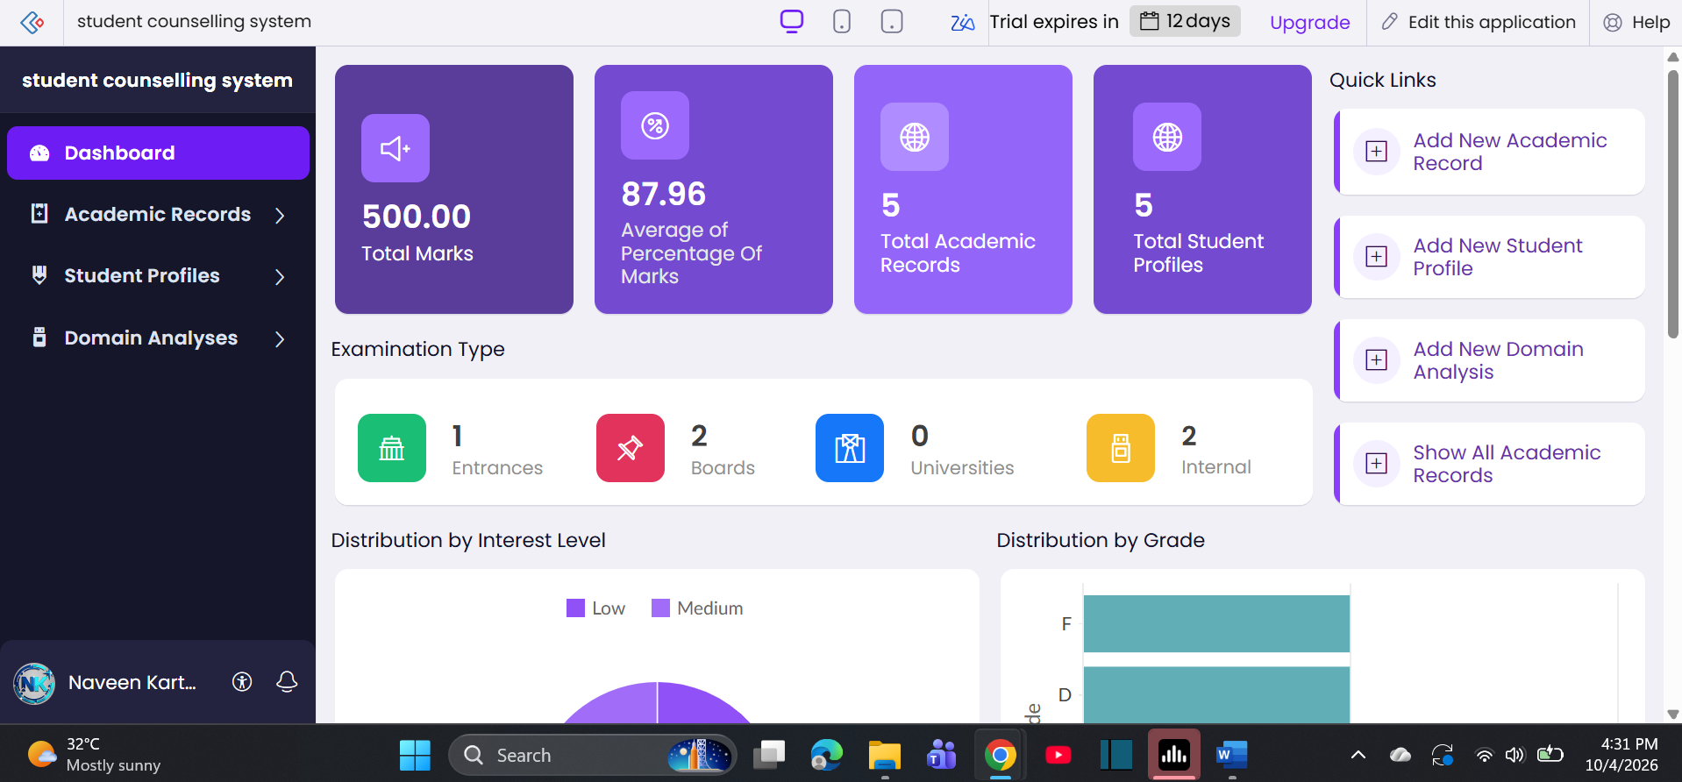

- AIM: To Create a simple cloud software application for Hospital information system for SIMATS
Hospital using any Cloud Service Provider to demonstrate SaaS with fields of patient name,
age, address, phone, email, Attender name, attender phone, doctor name, diseases, etc.
Output:
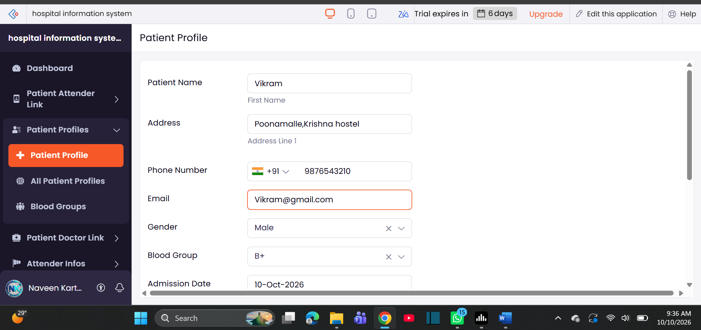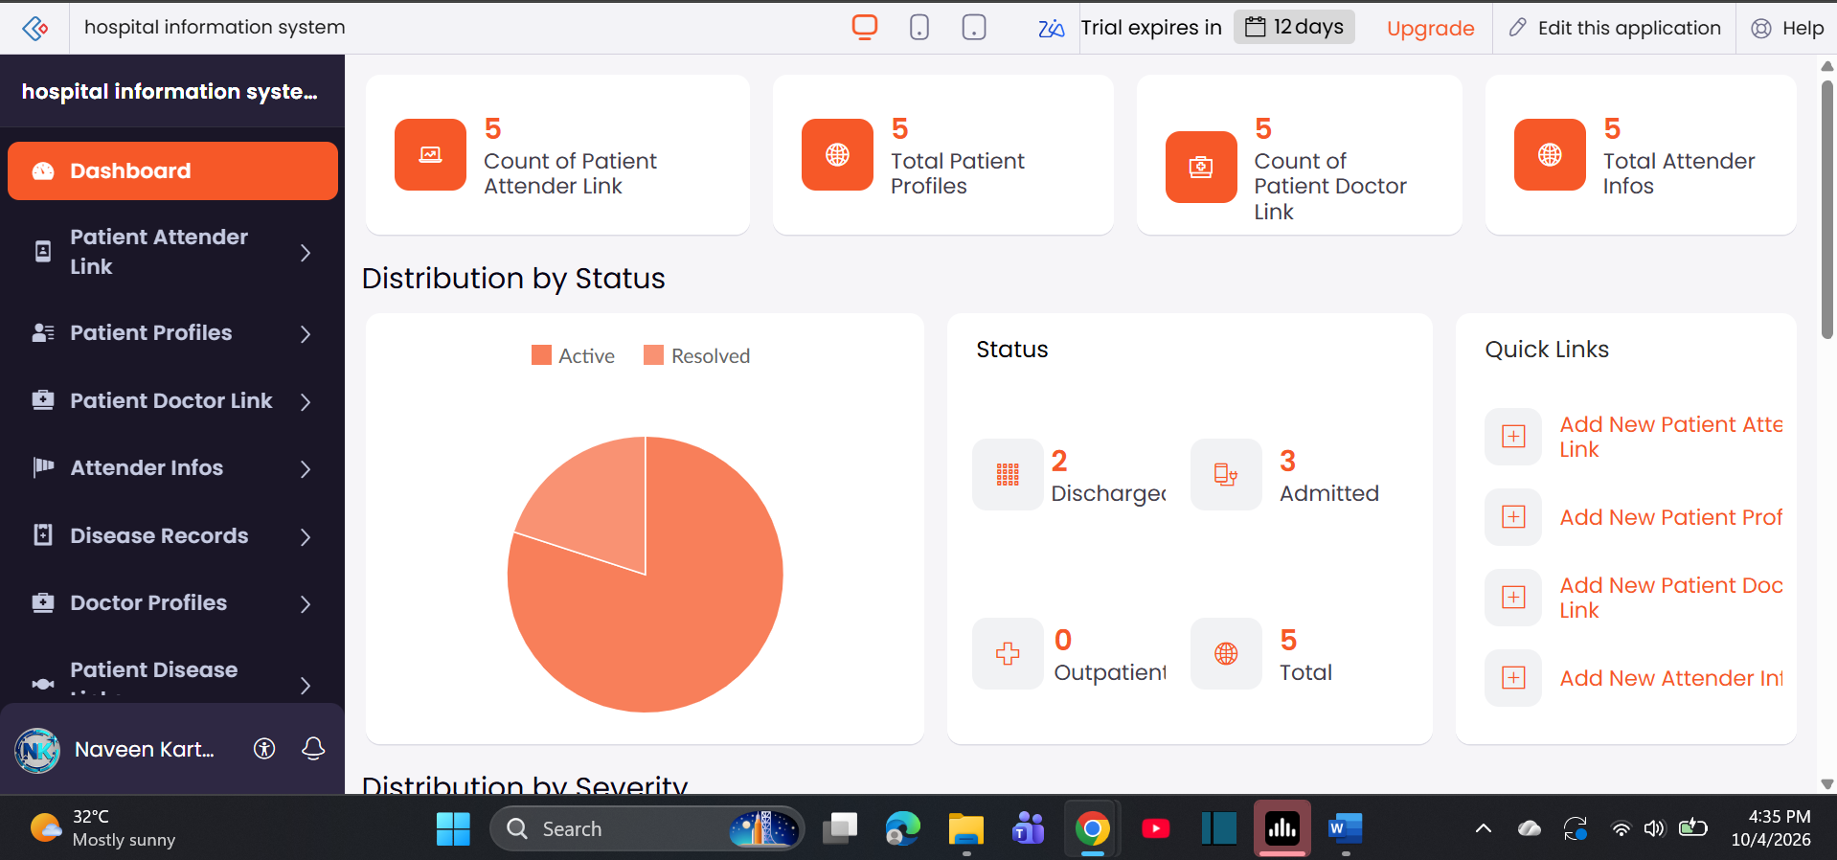

- AIM: Create a simple cloud software application to run a c program to display the student
information using any Cloud Service Provider to demonstrate SaaS with the template of
student name, reg no, address, phone, age, courses, grades and attendance report, progress
report, Semester mark sheet forms
Output:
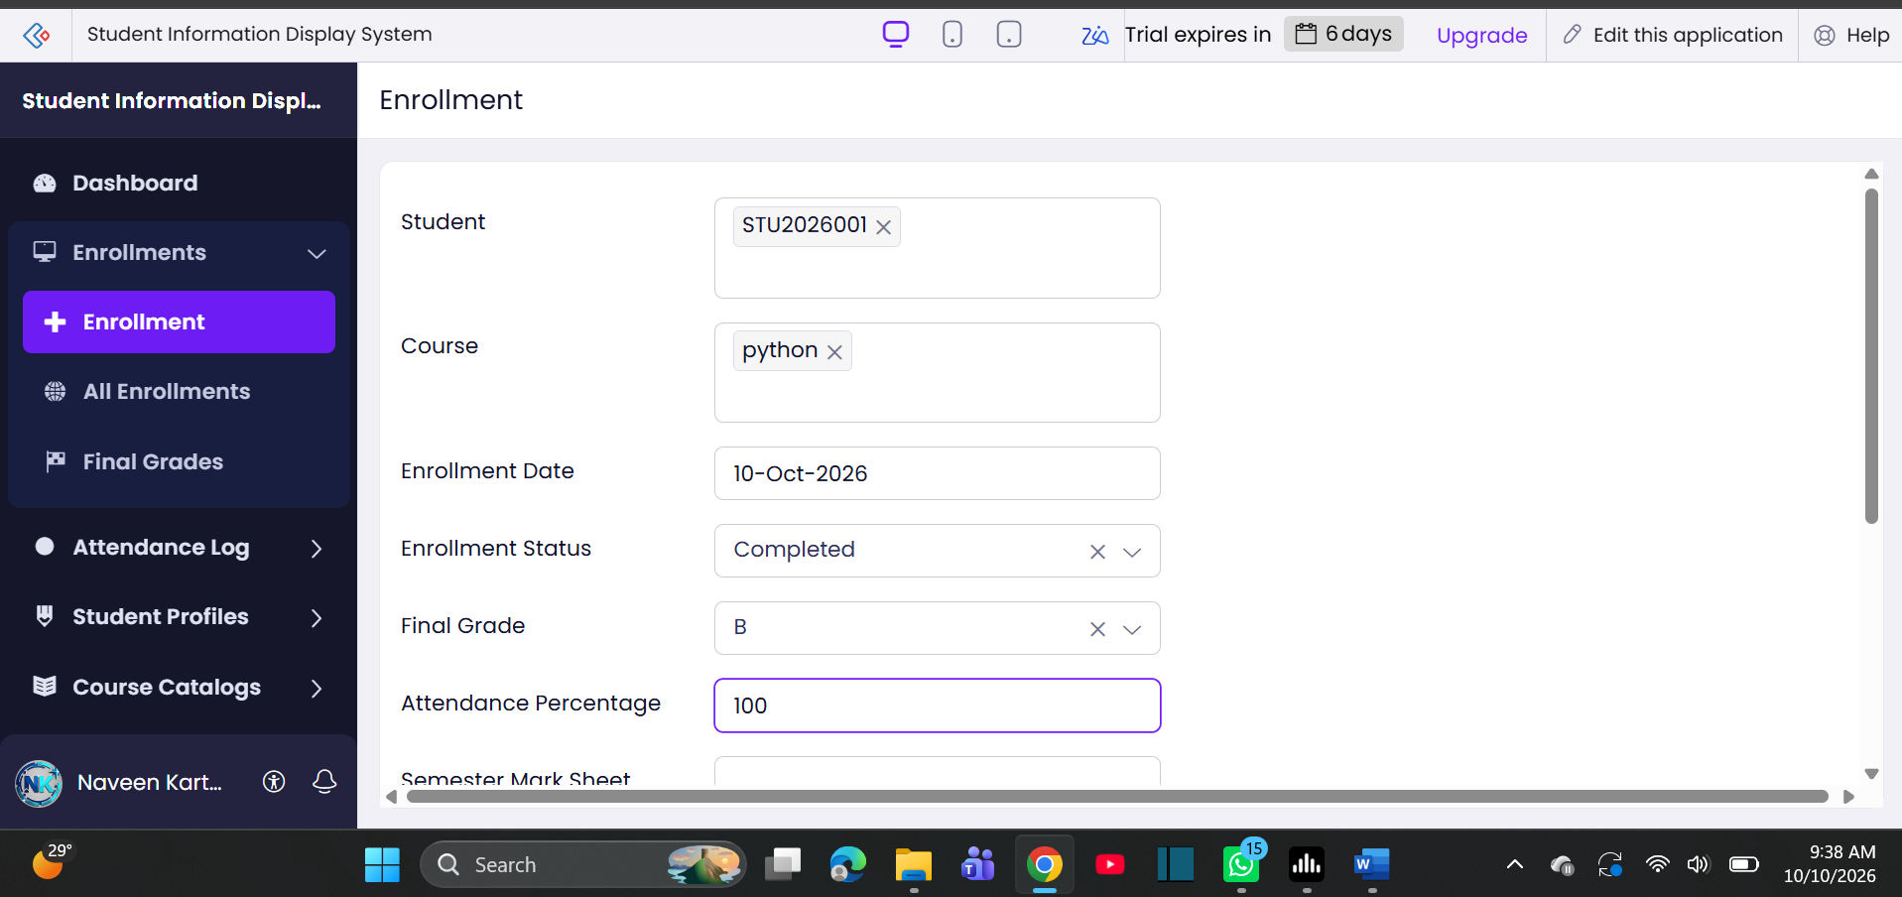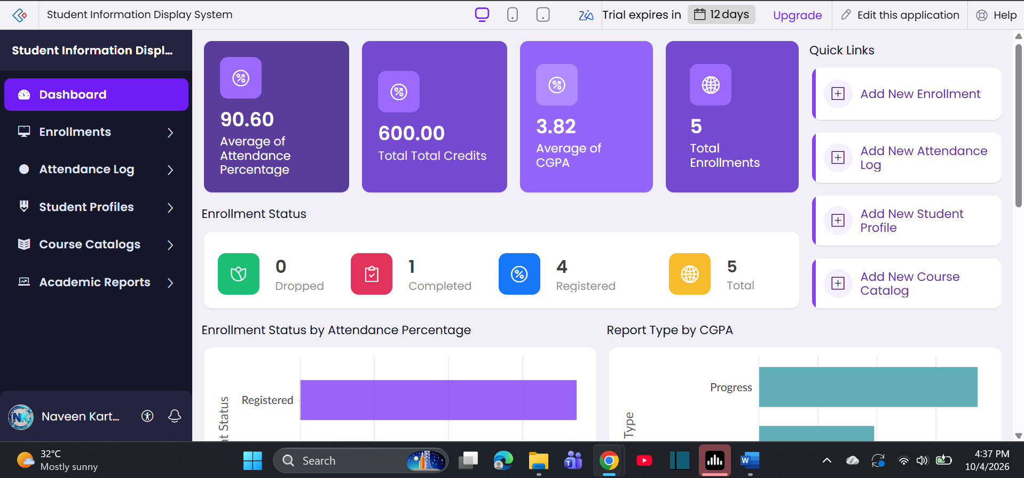

- AIM: To Create a simple cloud software application for online super market using any Cloud Service
Provider to demonstrate SaaS with the template of customer name, address, phone, email,
items, quantity etc. with the item classification form.
Output: 

